[support@centos a.v.shkurina]$ ll
total 12
-rw-rw-r--. 1 support support 28 Nov 8 14:55 create.users.with.sudo.retry
-rw-rw-r--. 1 support support 1349 Nov 8 16:39 create.users.with.sudo.yaml
-rw-rw-r--. 1 support support 18 Nov 8 16:33 list_of_hosts
[support@centos a.v.shkurina]$

[support@centos a.v.shkurina]$ ansible-playbook create.users.with.sudo.yaml -i list_of_hosts --become --extra-vars "ansible_user=bsv ansible_password=$(pass common/linux) ansible_sudo_pass=$(pass common/linux) ansible_ssh_common_args='-oStrictHostKeyChecking=no -oPubkeyAuthentication=no'"

PLAY [all] *********************************************************************************************************************************************************************************************************

TASK [Gathering Facts] *********************************************************************************************************************************************************************************************
ok: [vm-bisys01p]

TASK [Create a primary group for user] *****************************************************************************************************************************************************************************
changed: [vm-bisys01p]

TASK [Create a user] ***********************************************************************************************************************************************************************************************
changed: [vm-bisys01p]

TASK [Set expiratoin date] *****************************************************************************************************************************************************************************************
changed: [vm-bisys01p]

TASK [Adding user into sudo group if host OS is Ubuntu] ************************************************************************************************************************************************************
skipping: [vm-bisys01p]

TASK [Adding user into wheel group if host OS is RedHat, Centos] ***************************************************************************************************************************************************
changed: [vm-bisys01p]

PLAY RECAP *********************************************************************************************************************************************************************************************************
vm-bisys01p : ok=5 changed=4 unreachable=0 failed=0

[support@centos a.v.shkurina]$

[support@centos a.v.shkurina]$ cat list_of_hosts
[all]
vm-bisys01p
[support@centos a.v.shkurina]$

support@centos a.v.shkurina]$ cat create.users.with.sudo.yaml
---
- hosts: all

vars:
username: a.v.shkurina
uid: 850
gid: 850
comment: 'Shkurina Anastasiya Vladimirovna'
password_hash: '$6$do3bpcHGrBSNvJxy$HSrvw1awS.s/ni/QPhooNoKBQb7dE5gEHKn1JRRKrT2Q3mzgFrPaqXh5gtMIqQ1yY4cMDIoMiPWN9WYkbb8.P0'
# The account will expire after 3 days since now. One day has 86400 seconds.
expiration_date: "{{ '%Y-%m-%d' | strftime( (ansible_date_time.epoch | int) + (86400 * 3) ) }}"

tasks:
- name: Create a primary group for user
group:
name: "{{ username }}"
gid: "{{ gid }}"

- name: Create a user
user:
name: "{{ username }}"
uid: "{{ uid }}"
group: "{{ gid }}"
comment: "{{ comment }}"
shell: "/bin/bash"
password: "{{ password_hash }}"
update_password: on_create
create_home: yes
append: yes

- name: Set expiratoin date
command: chage -E "{{ expiration_date }}" "{{ username }}"

- name: Adding user into sudo group if host OS is Ubuntu
user:
name: "{{ username }}"
groups: sudo
append: yes
when: ansible_distribution == "Ubuntu"

- name: Adding user into wheel group if host OS is RedHat, Centos
user:
name: "{{ username }}"
groups: wheel
append: yes
when: ansible_os_family == "RedHat"

[support@centos a.v.shkurina]$

#
# Helped me links.
https://stackoverflow.com/questions/44841190/ansible-increment-date-by-x-days-minutes

http://www.mydailytutorials.com/working-date-timestamp-ansible/

https://ttl255.com/ansible-getting-date-and-timestamp/

http://www.mydailytutorials.com/ansible-arithmetic-operations/

https://serverfault.com/questions/728662/ansible-manipulate-file-with-a-date-format

https://stackoverflow.com/questions/31323604/ansible-date-variable

https://github.com/ansible/ansible/issues/10791

https://www.tecmint.com/manage-user-password-expiration-and-aging-in-linux/

https://lebenplusplus.de/2017/04/19/creating-users-and-their-passwords-with-ansible/

https://docs.ansible.com/ansible/latest/modules/user_module.html#user-module

https://docs.ansible.com/ansible/latest/modules/command_module.html#command-module

#
# 20181109

[support@centos a.v.shkurina]$ mkdir gitlab.tcsbank.ru
[support@centos a.v.shkurina]$ cd gitlab.tcsbank.ru/
[support@centos gitlab.tcsbank.ru]$

[support@centos gitlab.tcsbank.ru]$ git clone git@vm-gitlab01.tcsbank.ru:Ansible/accounts-management.git
Cloning into 'accounts-management'...
remote: Counting objects: 188, done.
remote: Compressing objects: 100% (15/15), done.
remote: Total 188 (delta 9), reused 0 (delta 0)
Receiving objects: 100% (188/188), 22.57 KiB | 0 bytes/s, done.
Resolving deltas: 100% (132/132), done.
[support@centos gitlab.tcsbank.ru]$

[support@centos gitlab.tcsbank.ru]$ cp ../create.users.with.sudo.yaml accounts-management/create_user_with_sudo_and_expire_date.yaml

[support@centos gitlab.tcsbank.ru]$ cd accounts-management/

[support@centos accounts-management]$ git add create_user_with_sudo_and_expire_date.yaml
[support@centos accounts-management]$ git commit --author='Sergey Belogrud <s.belogrud@tinkoff.ru>' -m "Draft template to allow Shkurina Anastasia make tasks to mount nfs-resources." create_user_with_sudo_and_exp
ire_date.yaml
[master d0ce68a] Draft template to allow Shkurina Anastasia make tasks to mount nfs-resources.
Author: Sergey Belogrud <s.belogrud@tinkoff.ru>
Committer: support <support@centos.7.3.work02.localdomain>
Your name and email address were configured automatically based
on your username and hostname. Please check that they are accurate.
You can suppress this message by setting them explicitly:

git config --global user.name "Your Name"
git config --global user.email you@example.com

After doing this, you may fix the identity used for this commit with:

git commit --amend --reset-author

1 file changed, 47 insertions(+)
create mode 100644 create_user_with_sudo_and_expire_date.yaml
[support@centos accounts-management]$ git status
# On branch master
# Your branch is ahead of 'origin/master' by 1 commit.
# (use "git push" to publish your local commits)
#
nothing to commit, working directory clean
[support@centos accounts-management]$

[support@centos accounts-management]$ git push origin master
Counting objects: 4, done.
Compressing objects: 100% (3/3), done.
Writing objects: 100% (3/3), 988 bytes | 0 bytes/s, done.
Total 3 (delta 1), reused 0 (delta 0)
remote: GitLab: You are not allowed to push code to protected branches on this project.
To git@vm-gitlab01.tcsbank.ru:Ansible/accounts-management.git
! [remote rejected] master -> master (pre-receive hook declined)
error: failed to push some refs to 'git@vm-gitlab01.tcsbank.ru:Ansible/accounts-management.git'
[support@centos accounts-management]$ git checkout -b 20181108_another_one_playbook_made_by_Sergey_Belogrud
Switched to a new branch '20181108_another_one_playbook_made_by_Sergey_Belogrud'
[support@centos accounts-management]$ ls -Alh
total 36K
-rw-rw-r--. 1 support support 2.9K Nov 8 21:03 add_sftp_user.yml
-rw-rw-r--. 1 support support 1.3K Nov 8 21:03 add_user.yml
-rw-rw-r--. 1 support support 261 Nov 8 21:03 change_root_pass.yml
-rw-rw-r--. 1 support support 1.4K Nov 8 21:06 create_user_with_sudo_and_expire_date.yaml
-rw-rw-r--. 1 support support 698 Nov 8 21:03 del_user.yml
drwxrwxr-x. 8 support support 185 Nov 8 21:13 .git
-rw-rw-r--. 1 support support 37 Nov 8 21:03 .gitignore
-rw-rw-r--. 1 support support 5 Nov 8 21:03 hosts
-rw-rw-r--. 1 support support 296 Nov 8 21:03 lock_user.yml
-rw-rw-r--. 1 support support 924 Nov 8 21:03 README.md
drwxrwxr-x. 2 support support 41 Nov 8 21:03 vars
[support@centos accounts-management]$

[support@centos accounts-management]$ git status
# On branch 20181108_another_one_playbook_made_by_Sergey_Belogrud
nothing to commit, working directory clean
[support@centos accounts-management]$

[support@centos accounts-management]$ git push origin 20181108_another_one_playbook_made_by_Sergey_Belogrud
Counting objects: 4, done.
Compressing objects: 100% (3/3), done.
Writing objects: 100% (3/3), 988 bytes | 0 bytes/s, done.
Total 3 (delta 1), reused 0 (delta 0)
remote:
remote: To create a merge request for 20181108_another_one_playbook_made_by_Sergey_Belogrud, visit:
remote: https://vm-gitlab01.tcsbank.ru/Ansible/accounts-management/merge_requests/new?merge_request%5Bsource_branch%5D=20181108_another_one_playbook_made_by_Sergey_Belogrud
remote:
To git@vm-gitlab01.tcsbank.ru:Ansible/accounts-management.git
* [new branch] 20181108_another_one_playbook_made_by_Sergey_Belogrud -> 20181108_another_one_playbook_made_by_Sergey_Belogrud
[support@centos accounts-management]$

https://gitlab.tcsbank.ru/Ansible/accounts-management/merge_requests/2
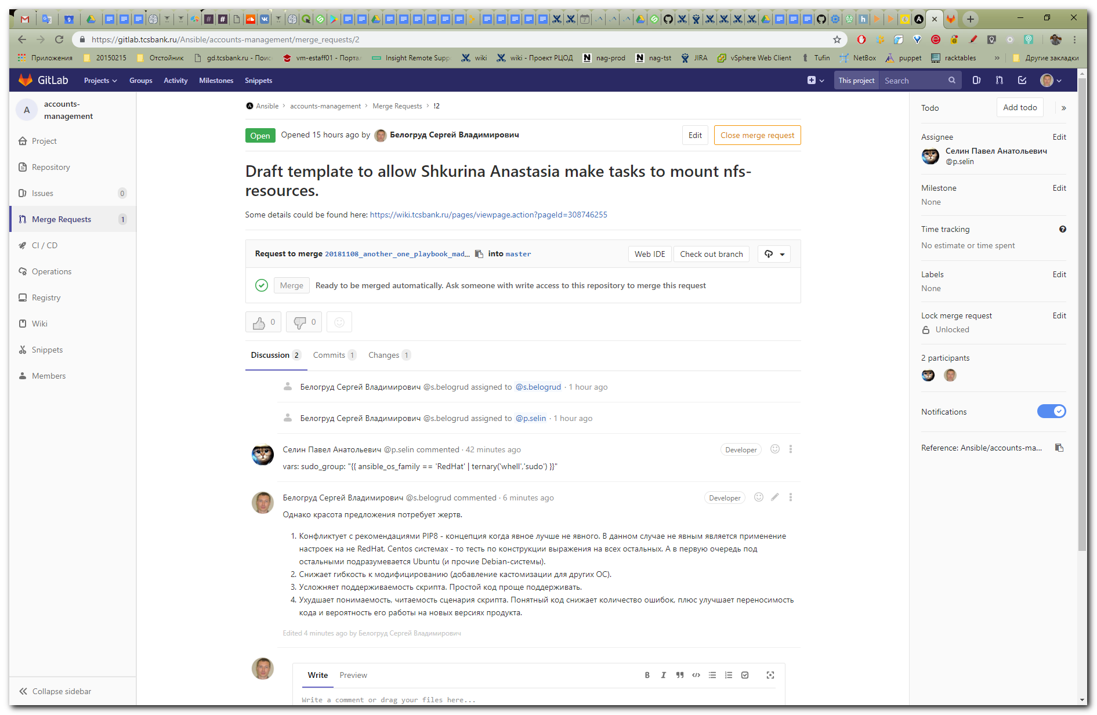

vars:
sudo_group: "{{ ansible_os_family == 'RedHat' | ternary('whell','sudo') }}"

Однако красота предложения потребует жертв.

Конфликтует с рекомендациями PIP8 - концепция когда явное лучше не явного. В данном случае не явным является применение настроек на не RedHat, Centos системах - то тесть по конструкции выражения на всех остальных. А в первую очередь под остальными подразумевается Ubuntu (и прочие Debian-системы).
Снижает гибкость к модифицированию (добавление кастомизации для других ОС).
Усложняет поддерживаемость скрипта. Простой код проще поддерживать.
Ухудшает понимаемость, читаемость сценария скрипта. Понятный код снижает количество ошибок, плюс улучшает переносимость кода и вероятность его работы на новых версиях продукта.

